Execution of POC
Workflow with VISION



Authors: | Phani Krishna P.
Reviewer:
Date:
Document Version Number:

Document History:
Version | AMENDMENT Date | Amendment Description
1.0

Table of Contents
1.0 INTRODUCTION 3
1.1 Purpose of the document 3
1.2 Scope 3
1.3 Intended Audience 3
2.0 DEFINITIONS 3
3.0 Pre-requisites 4
4.0 Execution 4
4.1 Creation of business process 4
4.1.1 Case 1 - Workflow 4
4.1.2 Case 2 – Workflow 7
4.1.3 Creation of Web Pages using Page Layout Designer 7
Login Page 7
4.1.4 Bonus Page (Name - Your choice) 9
4.1.5 Output Page (Name - Your choice) 10
4.1.6 Creation of a Page Link 11
4.1.7 Linking the components for case 2 12
4.2 Creation of a Connectivity Map 16
4.3 Adding a New eVISION external system in the environment 19
4.4 Managing login user in the integration server of the logical host 20
4.5 Creation of Deployment Profile 23
4.6 Executing the Web Page 23
4.7 Output Screen Shots 23

INTRODUCTION

1.1 Purpose of the document
The purpose of this document is to get familiarize with the usage of eVISION in the workflow using eInsight in JCAPS suite.

Scope
This document explains how to use eVision Studio in any workflows to create and deploy user interfaces for composite applications.
The scope of this document is limited to implementing a workflow scenario using eInsight and eVISION.

Intended Audience
This document is intended for experienced JCAPS consultants who need to create and deploy user interfaces for composite applications.

DEFINITIONS
Term | Use
Business Process | A collection of actions that take place in your company, revolving around a specific business practice.
Business Process Designer | An area in the Enterprise Designer where you view,  create, and edit your Business Process models
Business Rule Activity | Used to map and manipulate data in the Business Rule Designer.
Page Layout Designer | Used to create web pages with pre-built  GUI objects.
Page Flow Designer | Used to manage the web pages within a composite  Application.
Page Link | Used to create links to web pages and pass  parameters from one page to another.
Page Flow Engine | Orchestrates the system responses to the execution of web page component code.

Pre-requisites
- Successful Installation of eInsight.sar, eVISION.sar, eInsightDocs.sar (optional) and eVISIONDocs.sar (optional) in repository.

Execution
The scenario followed for workflow implementation using eVISION is as follows:
NOTE:
The scenario is like : A file is received and if the file consists of ‘Auto’ as text data then case 1 is executed and if the file consists of other than an ‘Auto’ then case 2 will be executed.
In the process, case 2 uses some eVision pages to process the data.
Create a New Project under the repository for this scenario. The Project is named as prjVISIONBP in this document.

Creation of business process

Case 1 - Workflow
- Right click on the project and select ‘New’ and choose ‘Business Process’.
- Choose the ‘Receive’ web service under Sun Seebeyond/eWays/File project and drag it on to the canvas.
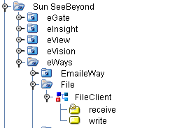
- Now choose the ‘Decision’ button from the toolbar on top of the canvas, drag it onto the canvas.
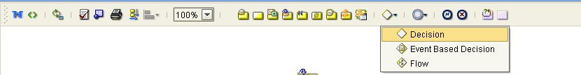

- Now connect the ‘Start’ button to the ‘File.receive’ and from ‘File. receive’ to the ‘Decision’ button.
- The Decision box will be passing the control depending upon the conditions . The 2 cases defined in this scenario are as follows:
  - CASE 1 : If the File Text contains ‘Auto’.
  - CASE 2: Other than ‘Auto’ as the File Content.
6)
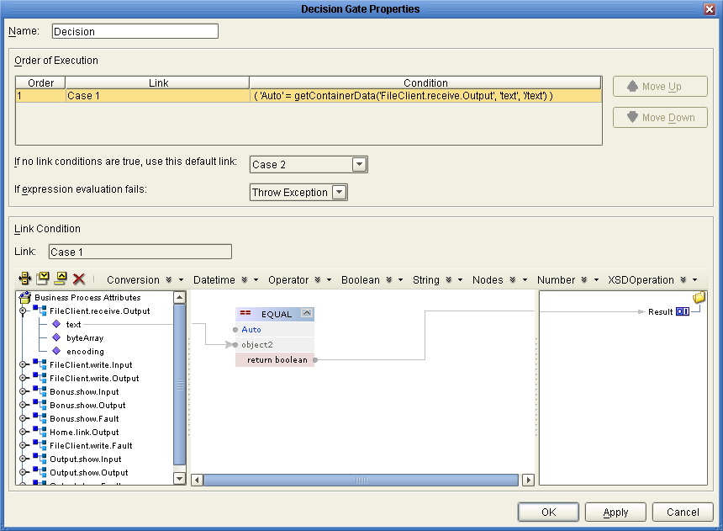
7) Now drag a ‘Business Rule’ from the tool bar of the canvas and link that to the case 1 and also link the ‘Business Rule’ to the ‘Decision.End’.
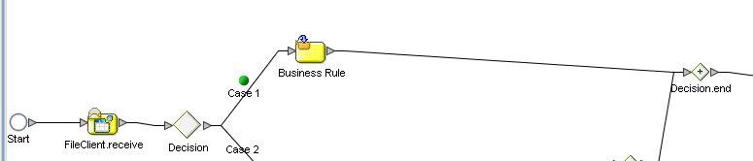

8) Now drag the ‘Write’ web service of File eWay from Sun Seebeyond/eWays/File package onto the canvas and link the ‘Decision.End’ to this service and from ‘File.write’ service to the End.

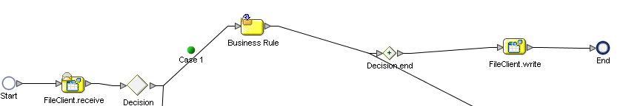
9) Now select the ‘Business Rule’ and click ‘Display Business Rule Designer’ on top of the toolbar.
Do the following mapping shown below. Define any string literal and map it to the ‘Text’ field of FileClient.write.input
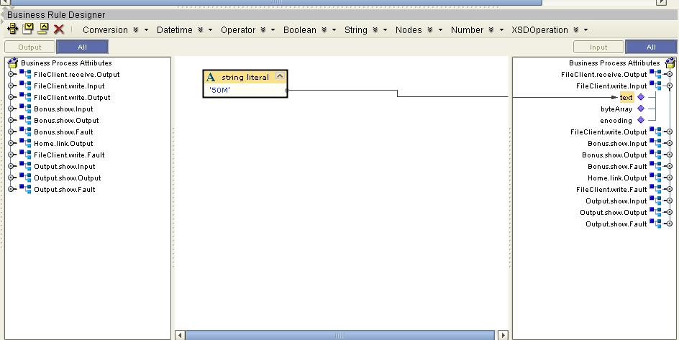

Case 2 – Workflow
In this flow, we require 3 Page Layouts and one Page Link.
Creation of Web Pages using Page Layout Designer

Login Page
- Right click on the project prjVISIONBP and select ‘NEW’ and choose ‘Page Layout’.
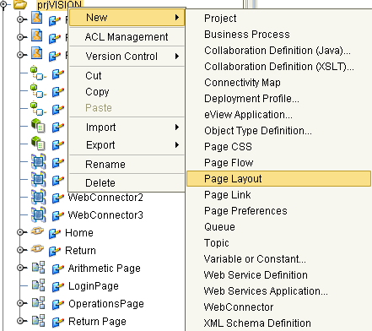

- Select the ‘Login’ Page from the option available and rename it to LoginPage and save the Page.
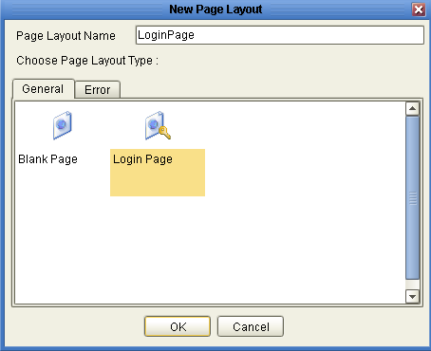
- Login page will be displayed as follows.
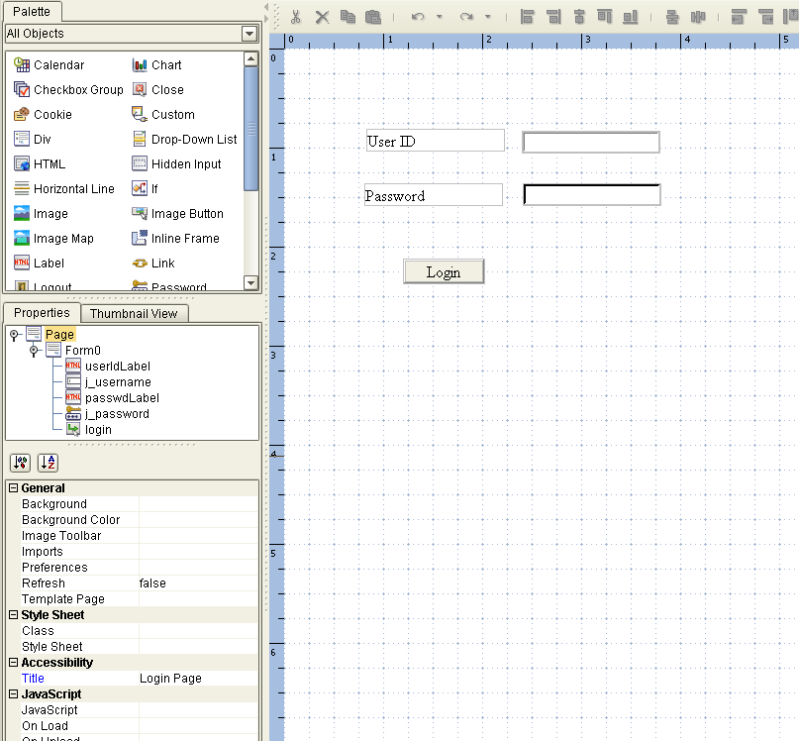

Bonus Page (Name - Your choice)
- Again right click on the project prjVISIONBP and select ‘NEW’ and choose ‘Page Layout’.
- Select Blank Page this time and rename it to ‘Bonus Page’ ( You can choose any name )
- This Web Page should contain 1 label, 1 text input field and a submit button.
- As per requirement, drag 1 label on the canvas from the Palette and rename them accordingly.
- Rename first label as ‘Bonus’.
- Drag 1 text input field from the Palette onto the canvas respectively and name that text field to your choice ( Here in this scenario specified as ‘Text_Input1’)
- Drag a submit button from the Palette onto the canvas and save the Page.
The final Web page would be like the below one
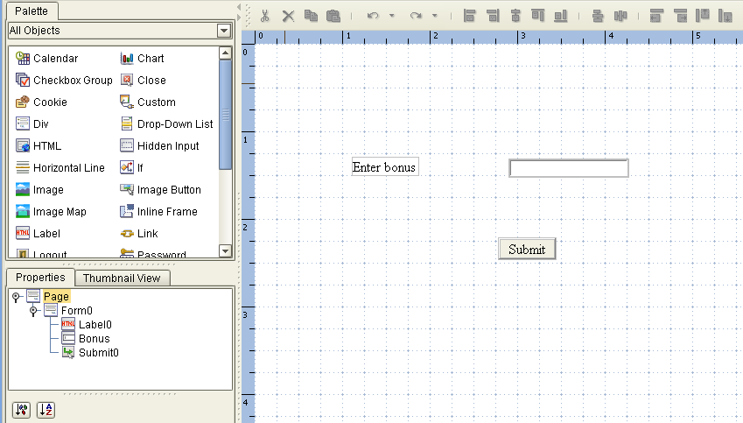

Output Page (Name - Your choice)
- Again right click on the project prjVISION and select ‘NEW’ and choose ‘Page Layout’.
- Select Blank Page this time and rename it to ‘Output Page’ (You can choose any name).
- This Web Page will contain 1 text field,1 hidden input and a submit button.
- Drag 1 test field, 1 hidden input and a submit button and name them accordingly.
- For the submit button, in the java script onClick () method , write window.close();
- The final Web page would be like the below one
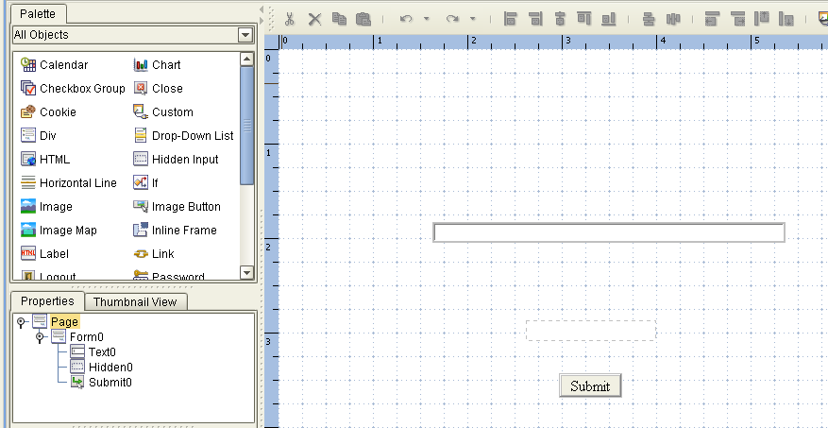

Creation of a Page Link
- Right click on the project and select ‘NEW’ and choose ‘Page Link’ option.

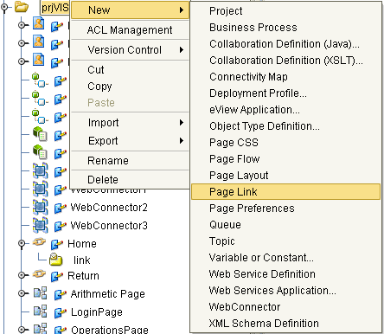

- Rename the Page link to a new name like ‘Home’ (Your choice).
- There will be a check box down to the Page Link Name as ‘ Designate as home page ‘ . Please select that check box.
The final Page Link configuration would be like the below one
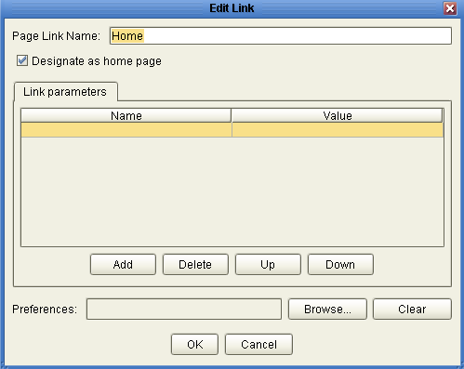

Linking the components for case 2

- Select the ‘Event Based Decision’ option from the Branching activities button in the Process Flow toolbar and drag it onto the canvas Please see the below figure for the same.
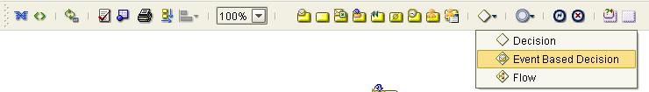

- Once dragged onto the canvas, connect it to the case 2 button.
- Now drag the ‘show’ web service of the ‘Bonus’ page and link from ‘Event Based Decision’ to the “Bonus. show’ operation.
- Now from the Enterprise Explorer window, select the ‘Link’ service of the ‘Home’ Page Link, drag it and map (drop) it to the ‘Message Event’ ( between Event Based Decision and Bonus.show web service ) onto the canvas.
Observe the ‘Message Event’ will be changed to ‘Home.link’ in name.
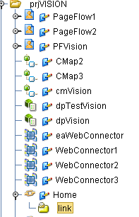

- Select the ‘Home.link’ and click the ‘Show Property Sheet’ button in the tool bar. You will see the list of properties updated automatically.
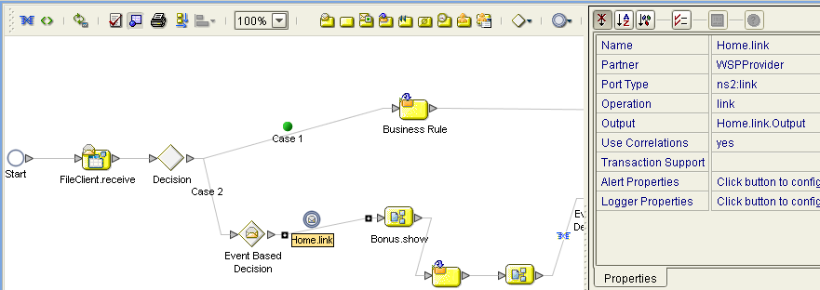

- Drag a ‘Business Rule’ from the toolbar on top of the canvas and place it after ‘Bonus.show’ operation.
- Drag the ‘show’ operation of the ‘Output’ page on the canvas besides the new business rule created.
- Now link the ‘Output. show’ to ‘Event Based Decision.End’ . Right click on the link between ‘Output. show’ and ‘Event Based Decision.End’ and choose ‘Add Business Rule’.
- From ‘Event Based Decision.End’ link to the ‘Decision.End’ . The final workflow will be like the below.

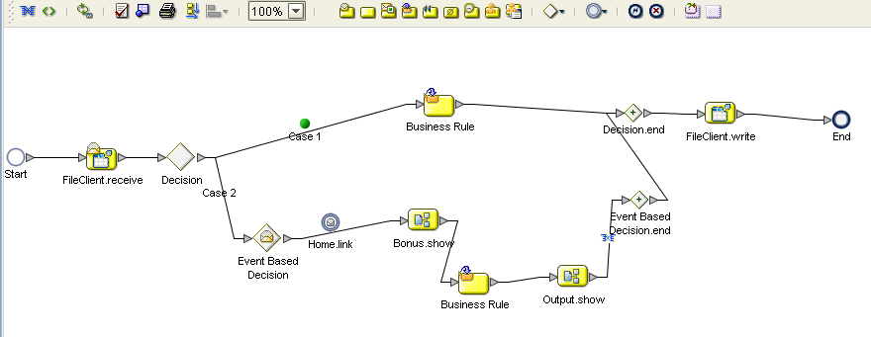
- Now select the ‘Business Rule’ in between Bonus.show and Output.show and select the ‘Display Business Rule Designer’ on top of the tool bar canvas and do the following mapping.
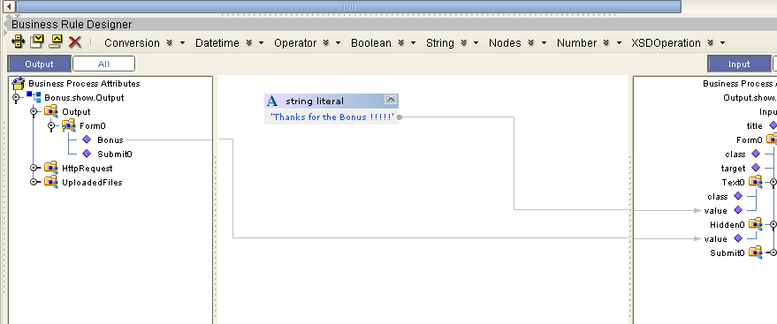

- Now select the ‘Business Rule’ in between Output.show and ‘Event Based Decision.End’ and select the ‘Display Business Rule Designer’ on top of the tool bar canvas and do the following mapping.
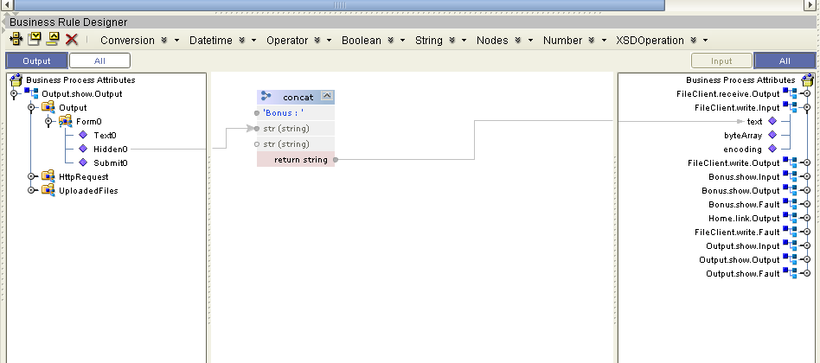

NOTE :
An Email ‘Send message’ service can also be used in this scenario for the notification. [ Currently doesn’t have SMTP 25 port open on my machine for sending]

